

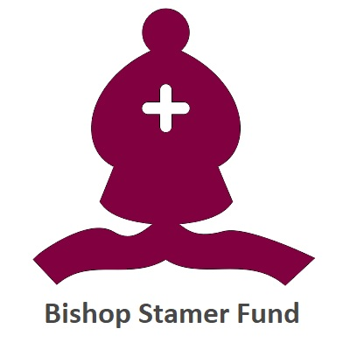

Application Form
(From March 2024)

BEFORE YOU BEGIN YOUR APPLICATION
Please read the following criteria and guidance to ensure that you are eligible to apply for a grant

The Bishop Stamer Fund will award small grants, up to the value of £500, to people who may need extra help or support.

Any applicants must be at least 50 years old and have health problems in order for the application to be considered, and there is a preference towards people who are elderly, (70+), and infirm.

Funding can be used to help applicants or their carers with a specific cost, or to pay for a piece of equipment that might be helpful to them. It can also be used to help to pay for the provision of services or facilities. Any costs should be related to the applicants age or health condition.

These costs, items or services should not be available from any statutory source.

In all instances this form should be fully completed and answered. Incomplete applications cannot be considered.

A letter or statement of support from a doctor, health visitor or social worker, should also be provided. This should be on letterheaded paper and provided with the application.

If you need any further information or would like help completing this application form please get in touch with our grants team, and they will be able to assist you.

You should also ensure that you meet the following criteria;

- You should be resident in North Staffordshire, which for the purposes of this grant includes the following areas;

- Stoke on Trent
- Newcastle under Lyme
- Staffordshire Moorlands
SECTION 1.1
About you

We need this information to ensure that you are eligible for a grant from the Bishop Stamer Fund, and to contact you if we require more information.

Name
Date of Birth
Address
Telephone
E-mail Address

SECTION 2.1
About your income

Please provide details of your monthly income. We need this information to determine your financial need. We can only fund equipment or activities if you cannot afford to pay for it yourself.
Employment | £
Benefits | £
Partner's Income | £
Any other income | £
Total Income | £

SECTION 2.2
About your expenditure

Please provide details of your monthly expenditure. We need this information to determine your financial need. We can only fund activities or equipment if you cannot afford to pay for it yourself.
Rent / Mortgage | £ Please leave this answer blank if paid by Housing Benefit
Council Tax | £ Please leave this answer blank if paid by Council Tax Benefit
Gas / Electricity / Water | £
TV / Telephone / Internet | £
Food | £
Clothing | £
Vehicle | £
Other (eg. Loans / Catalogue / HP) | £
Total Expenditure | £

SECTION 3.1
About the grant you are applying for

We need this information to make sure that the activity or equipment is the sort of thing we can support. We also use this information to make sure that there will be a benefit to you.
Please give details of any condition or circumstance that makes a grant necessary.

Please explain how you will spend any grant awarded. You should also include details of why you think this activity or equipment will benefit you, and how it will improve your life.

SECTION 3.2
The things you need the grant to pay for

Please break down the requested costs by item or service. If we are unable to fund the whole cost we may be able to fund some of the individual costs.
ITEM OR SERVICE | PROVIDER | COST
TOTAL COST

SECTION 4.1
Further Information

The information provided in this form will be stored electronically by The Community Foundation for Staffordshire and will be used to assess the application and determine the eligibility for a grant from this scheme.
If a grant is awarded the information will be retained for a period of 7 years. This is because a financial award will be made, and we must retain records relating to financial transactions for 7 years.
If a grant is not awarded the information will be retained for a period of 2 years. This is because in the year following the decision, we will be audited, and may have to show evidence as to why we did not make an award.
Please ensure you read and sign the declaration on the next page. We will not be able to accept unsigned applications.

SECTION 4.2
Submitting your application

As well as this application form we will need a letter from a doctor, nurse, health visitor or social worker, confirming that you will benefit from the requested items, and how you will benefit.
This should come on letterheaded paper and contain the contact details of the person providing the reference.

Once this information is complete, please return the completed application by either post or e-mail.
By post to;
The Community Foundation for Staffordshire
Philanthropy House
Priestly Court
Staffordshire Technology Park
Stafford
ST18 0LQ

By e-mail to;
office@staffordshire.foundation
SECTION 5.1
Declaration
Please read this section carefully. We are unable to accept an application if this section has not been completed. It will give details of how we will use the information you have provided in this form, and how we will store it.
- By signing you agree that you are making an application for funding and that the information that you have provided is correct to the best of your knowledge.
- You accept that if any information changes prior to an award being made you will need to notify The Community Foundation at the earliest opportunity.
- You understand that any grant awarded will be made directly to the supplier or service provider on your behalf. There will be no direct financial award.
- You understand that The Community Foundation will record the information contained on this application form so that we can make an informed decision of whether we can offer you support.
- You understand that if you are successful in receiving an award, The Community Foundation will retain the information on this application form for 7 years. If you are not successful, the information will be retained for 2 years.
- You understand that if more information is needed, The Community Foundation for Staffordshire will contact you using the details you provided in section 1.1, and you consent to this contact.
- You understand that the decision of the grant making panel is final. However, if you think a mistake has been made, you can ask for the application to be reassessed.

Please tick ONE of the following boxes;
Please keep me updated with grants information that may be of interest to me OR
I do not wish to receive any further information about grants

Please tick ONE of the following boxes;
Please keep me updated with information about community events that may be of interest to me OR
I do not wish to receive any further information about community events

Signature

Date

